|  |  |  |  |  |  |
| --- | --- | --- | --- | --- | --- |
| Date | 7-Dec-22 | | | Tester Name | Mohammad Yusuf |
| Environment | Penfax - Test | | | Login used |  |
| Operating System | Windows | Version: | Update: | | |
| Software Used | Select Software | Version: | Update: | | |
| Select Software | Version: | Update: | | |
| Release version |  | | | | |
| Title |  | | | | |
| Test Type | Regression | | | | |
| Test Scenario |  | | | | |
|  |  | | | | |
| Expected Results |  | | | | |
| Pass/Fail | Select | | | JIRA# | N/A |

Describe your steps with screenshots:

Search for the member in penfax

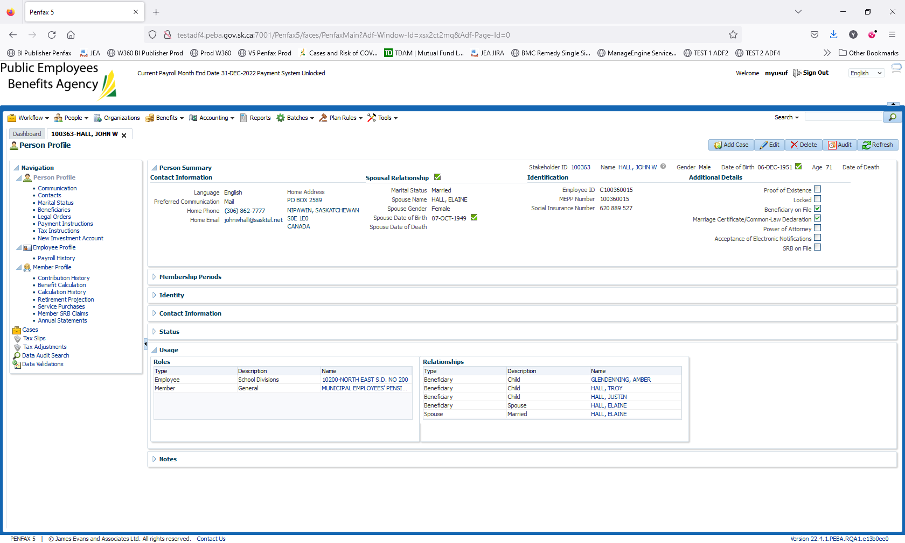

Go to Navigation ->Person profile -> Marital Status

Details in relation to the relationship should be populated

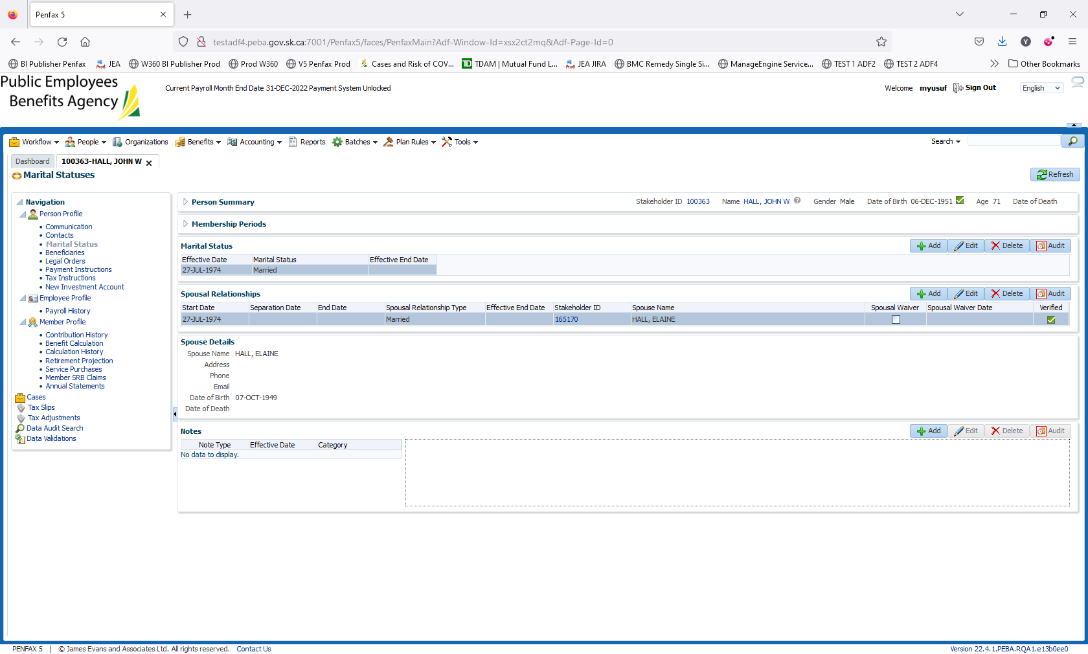

* **NOTE:** The **Effective Date** of the **Marital Status** and the **Start Date** of the **Spousal Relationships** were set to **01-Jan-1900** during the conversion. This ensures that, as a default, the entitlement period includes the member’s entire contributory period.

Correct the date by clicking edit on Marital Status

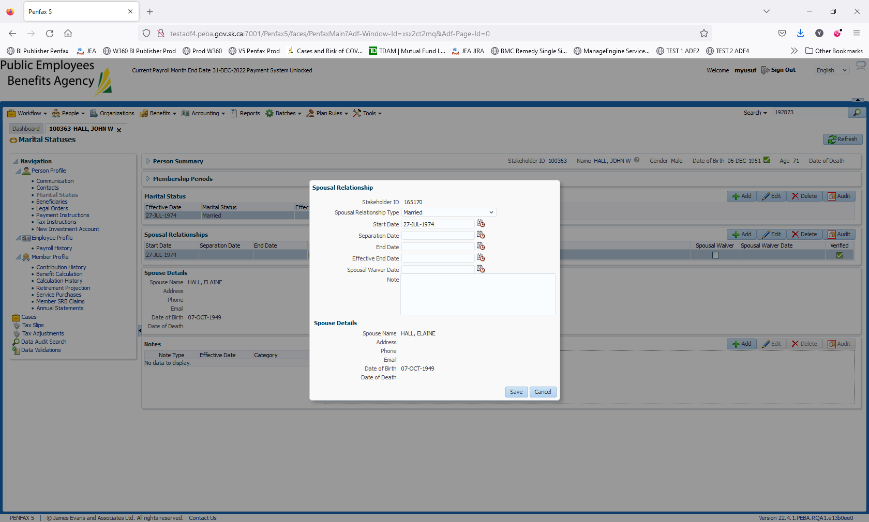

Edit the date to 31 Aug. 2022. Click save

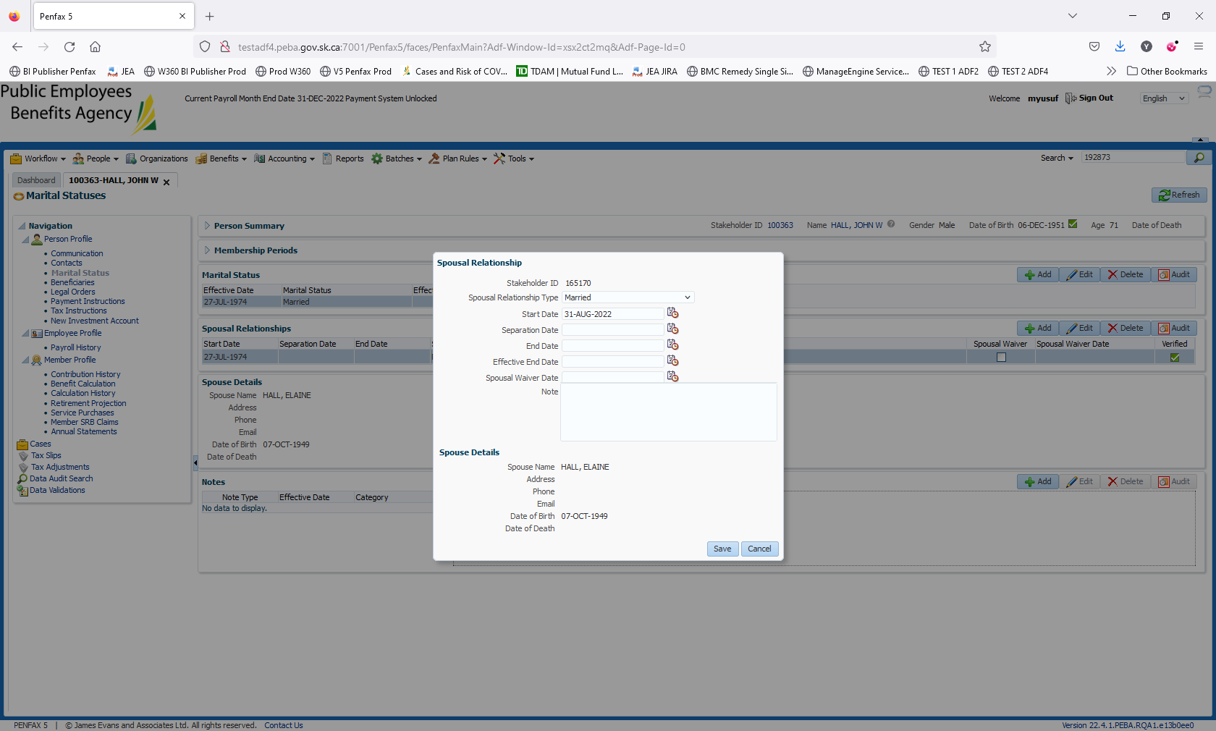

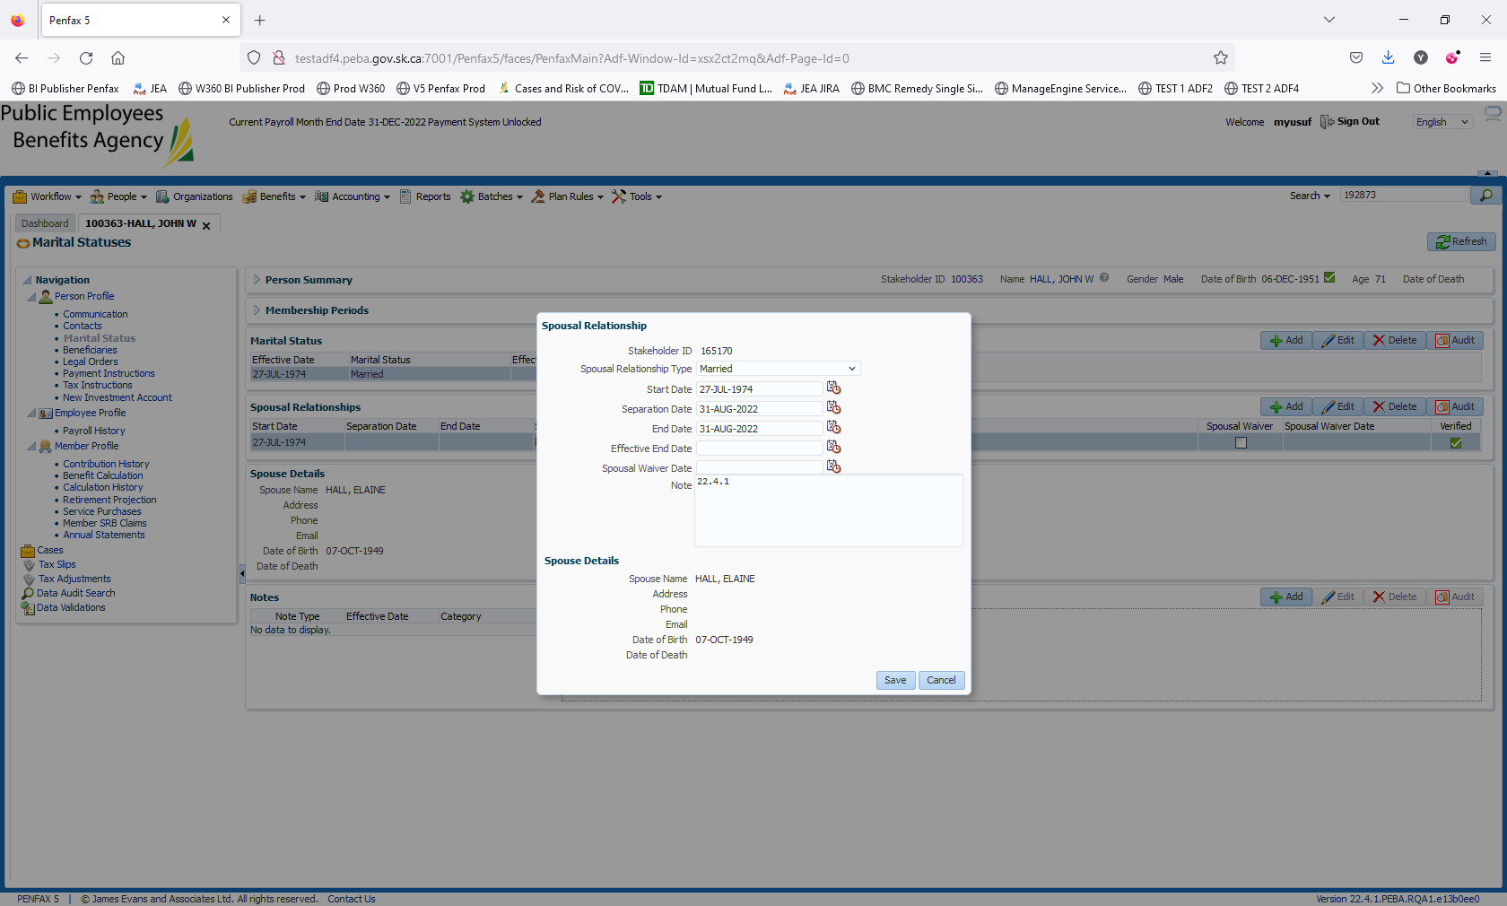

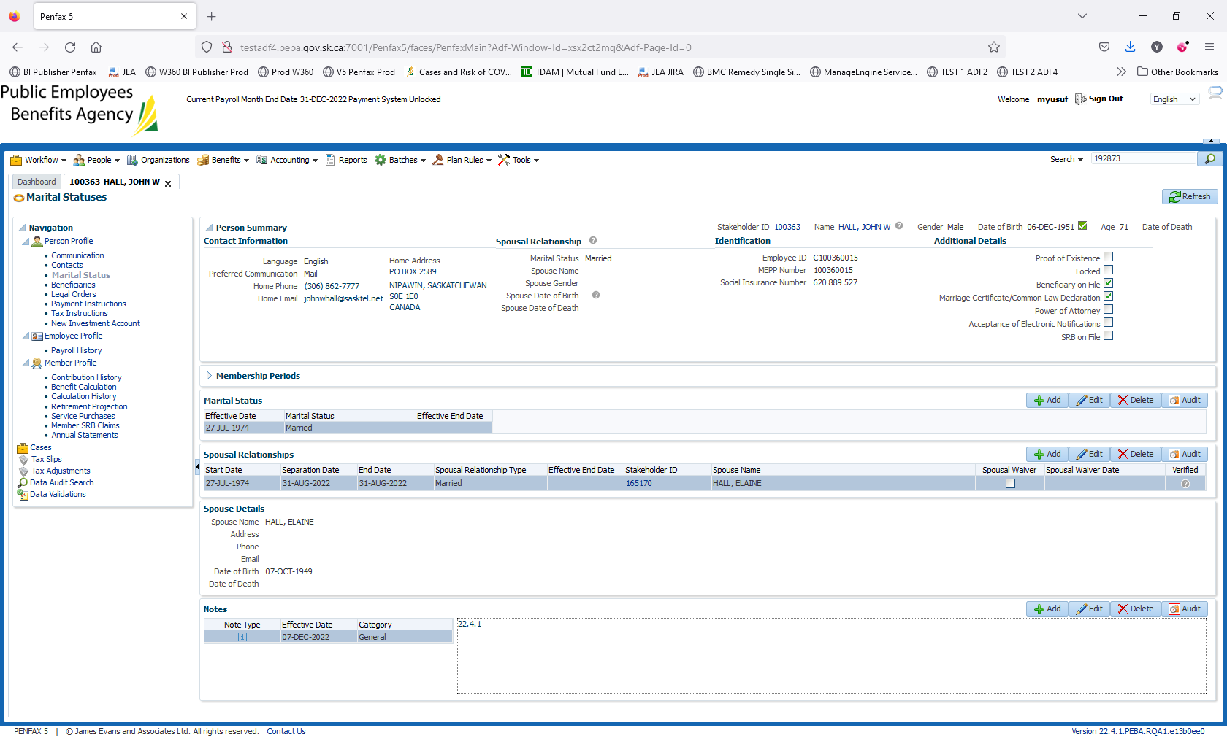

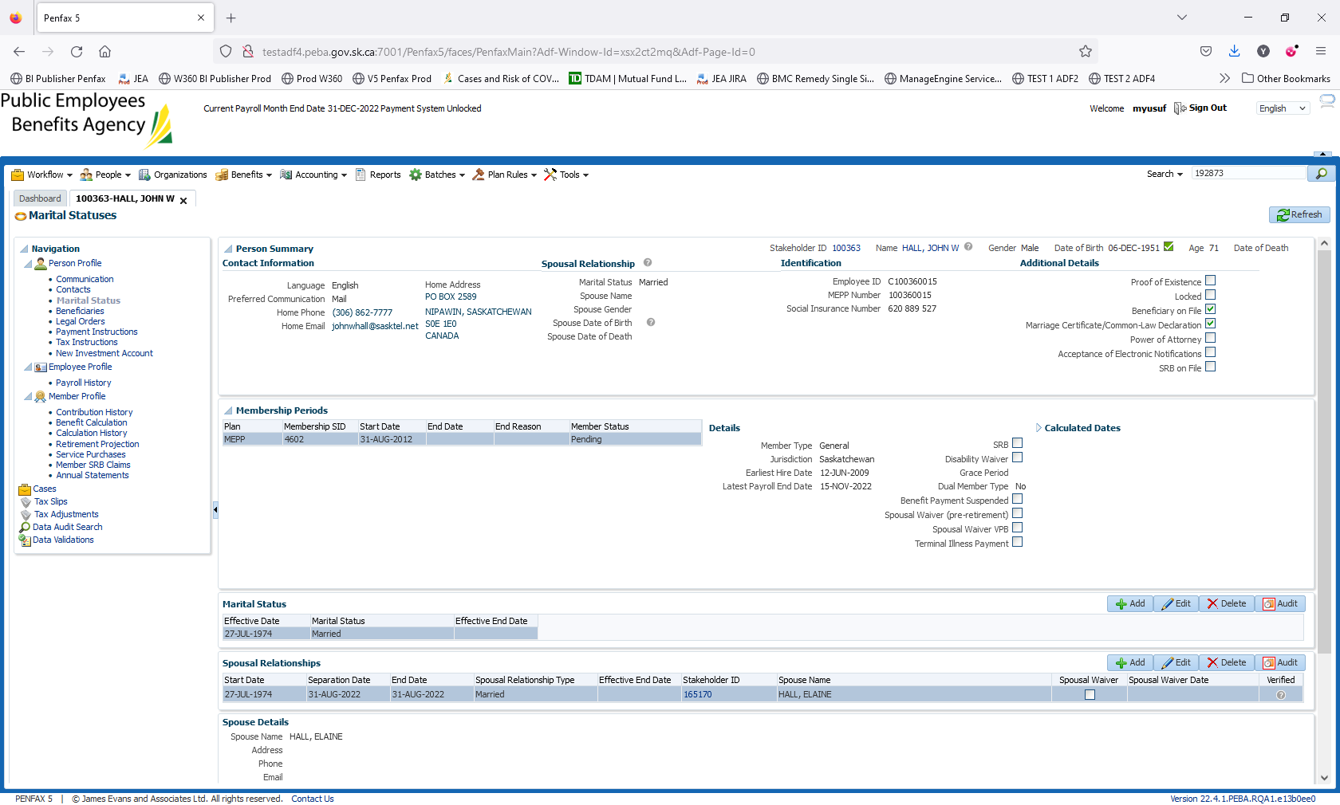

Navigate to Member Profile -> Member SRB claims

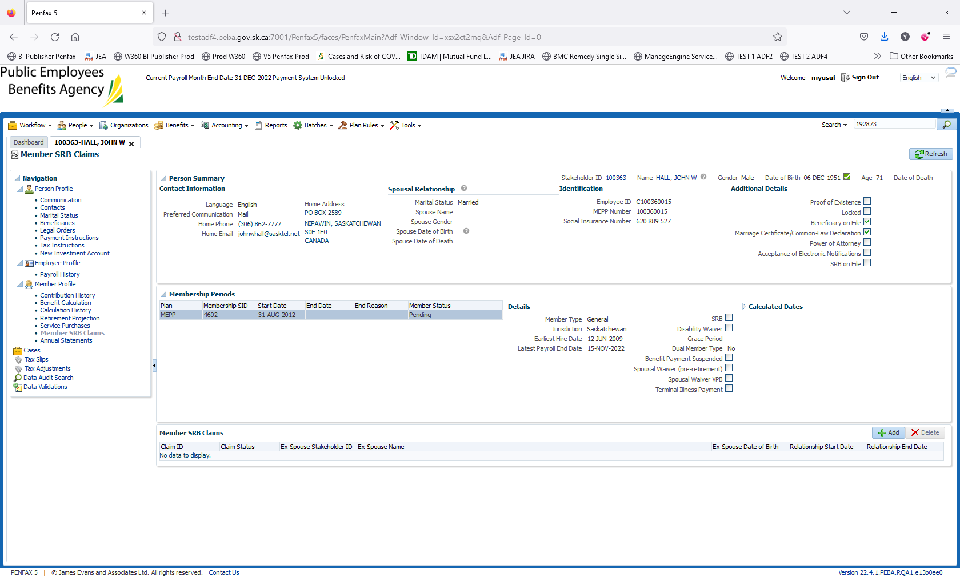

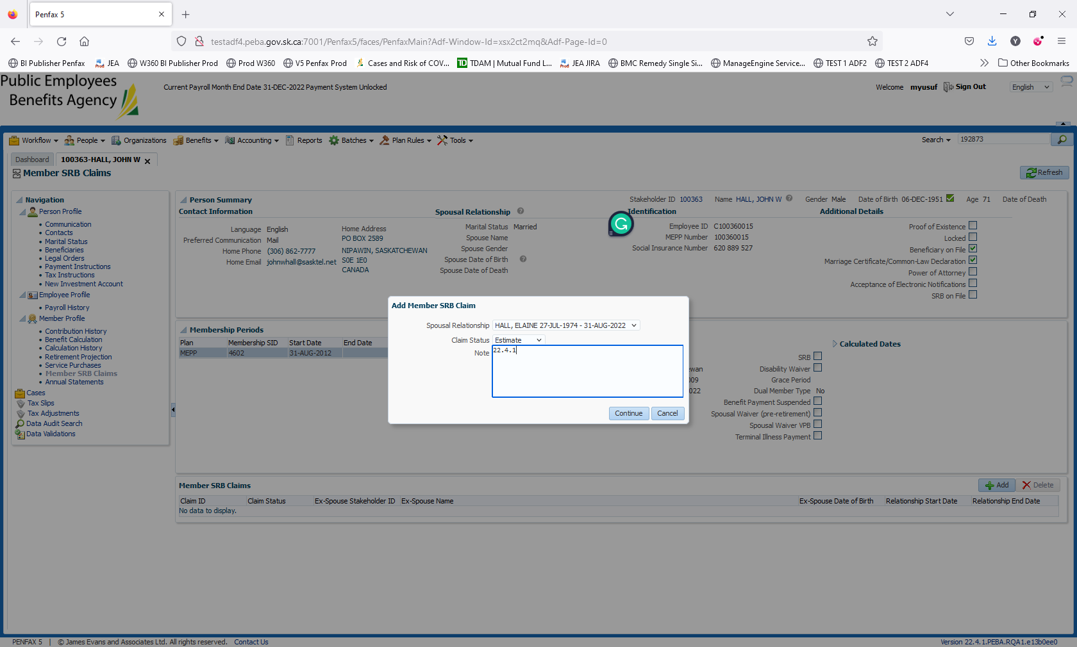

In Member SRB claims click add

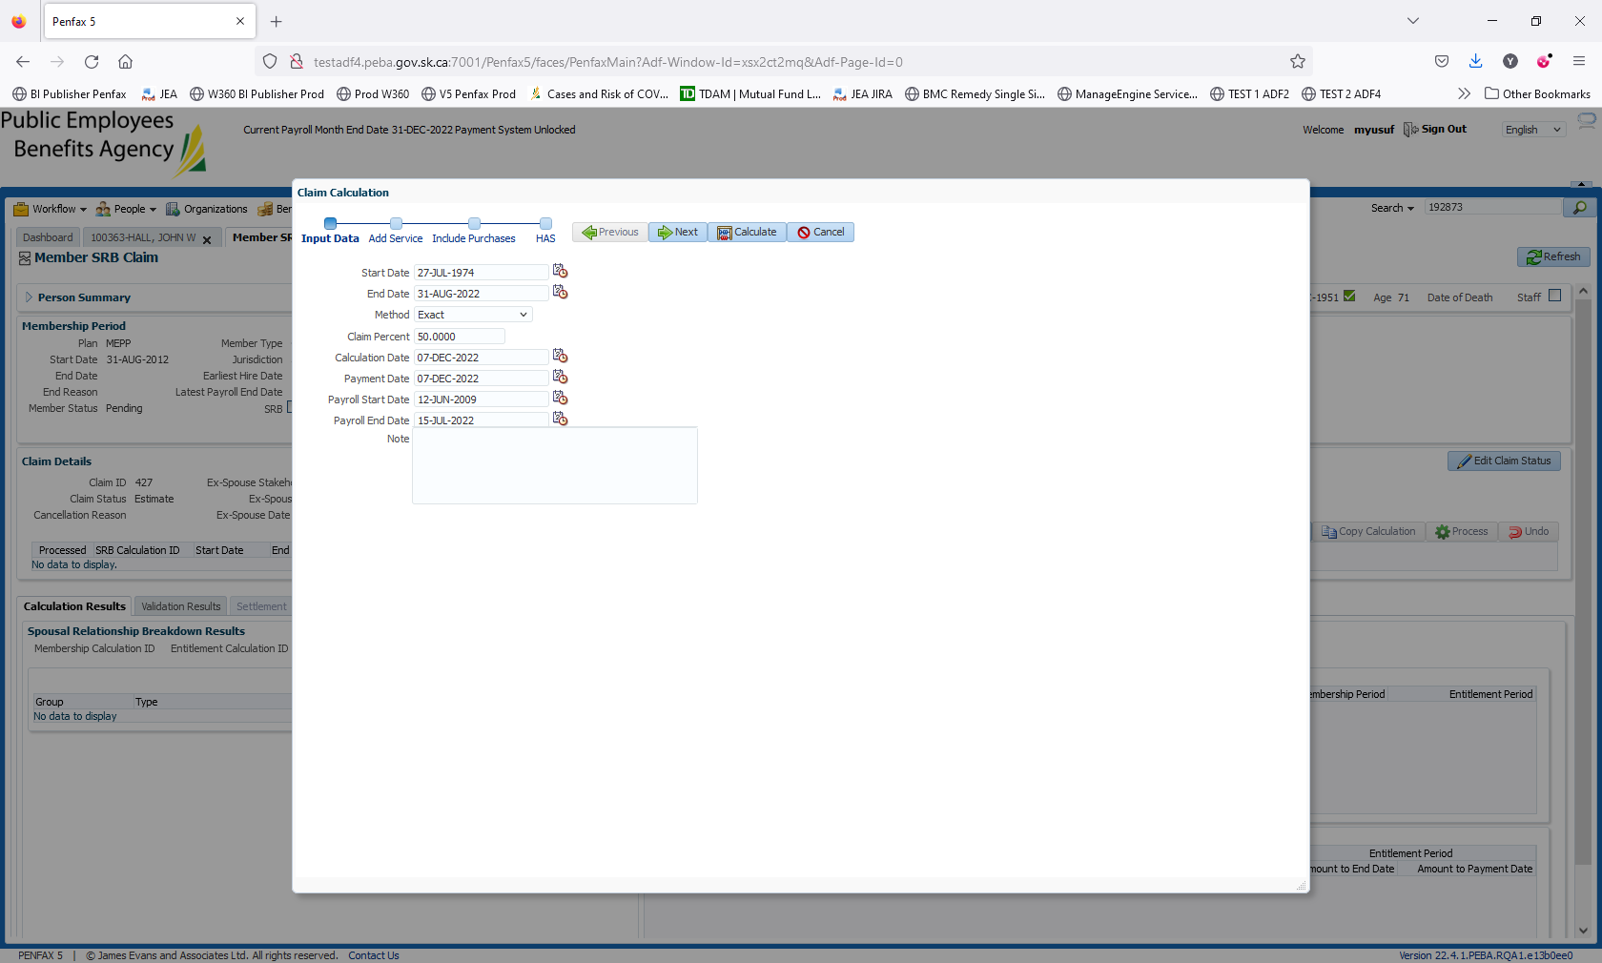

Enter the End Date. Click on Estimate

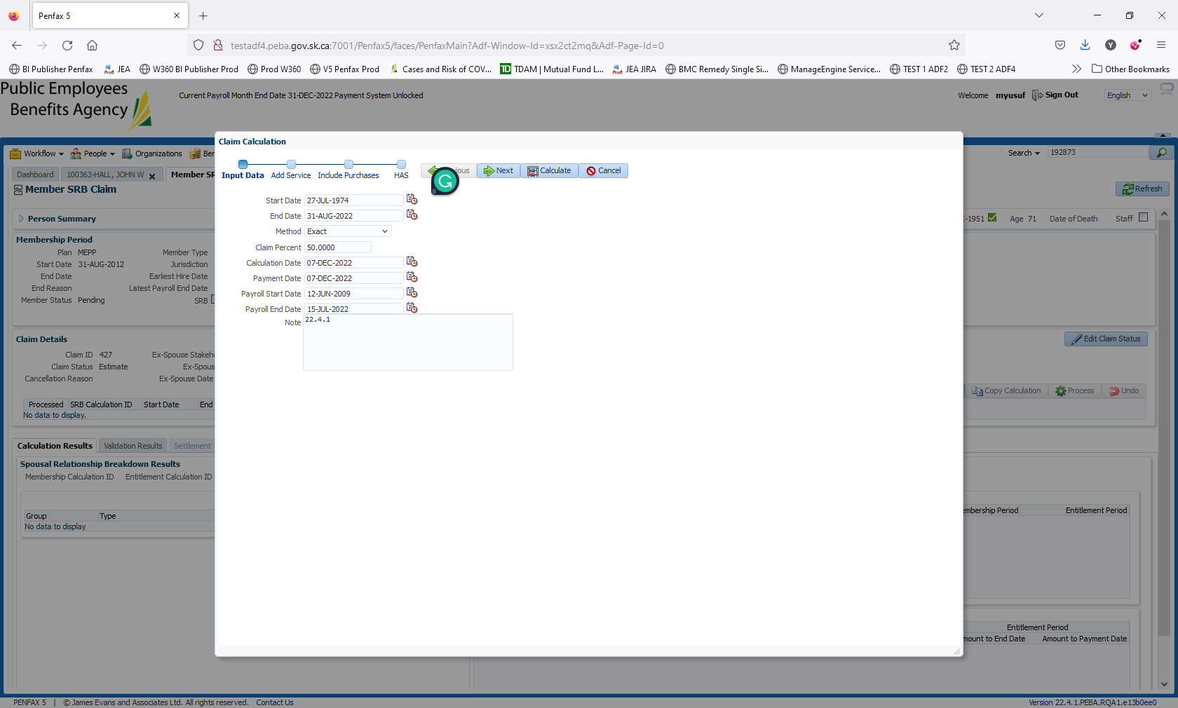

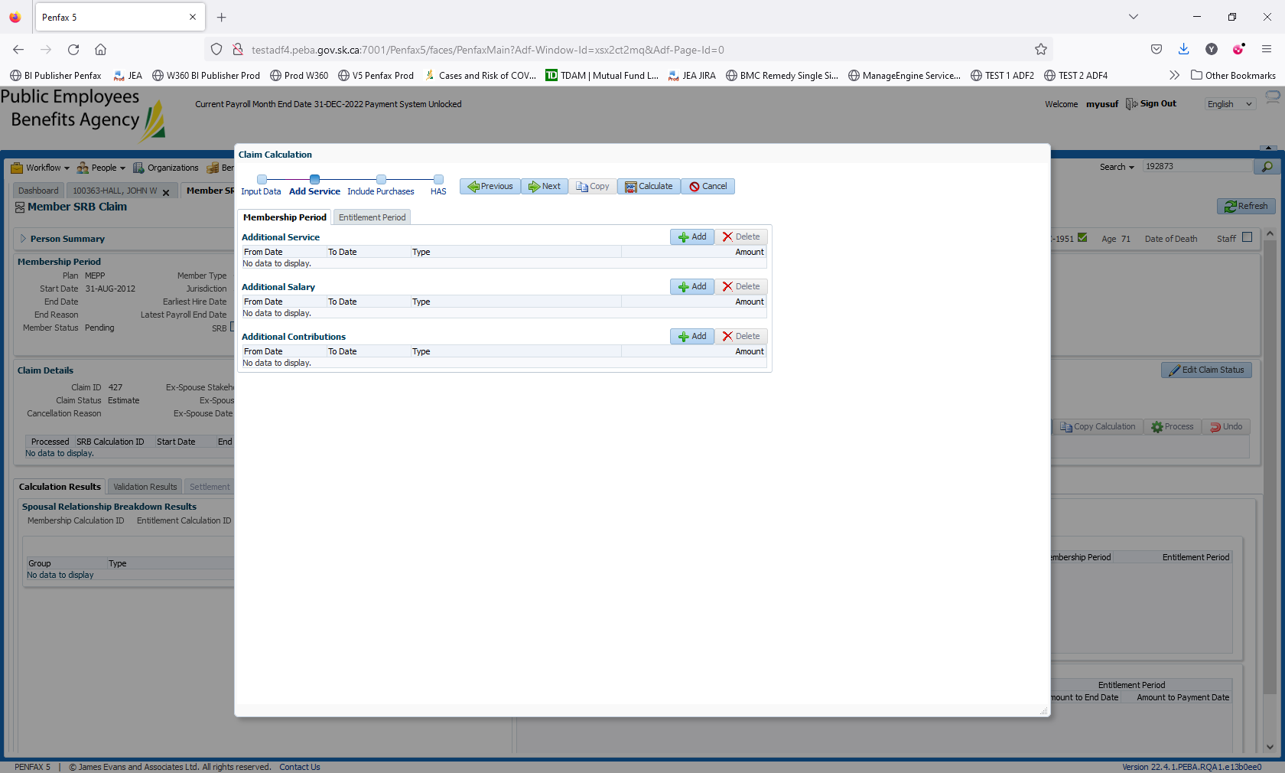

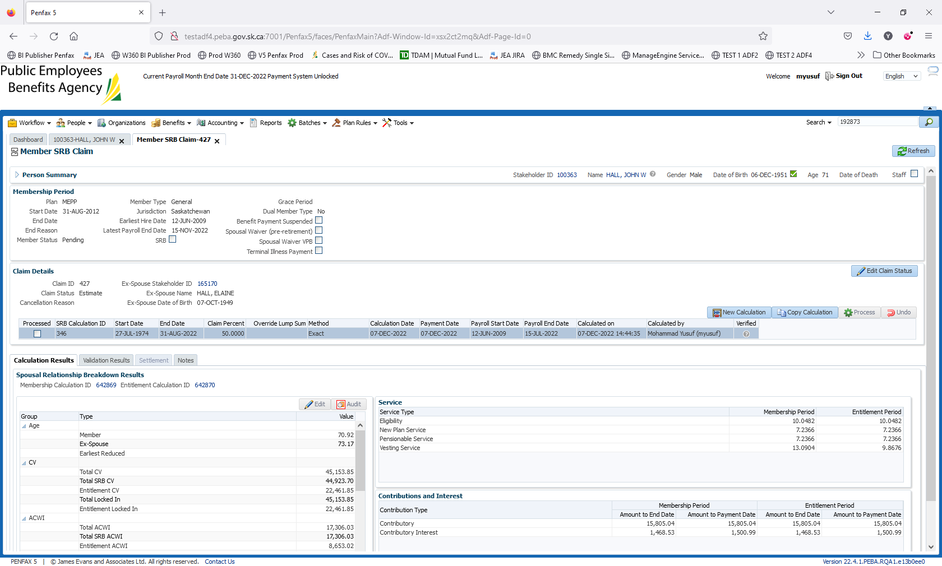

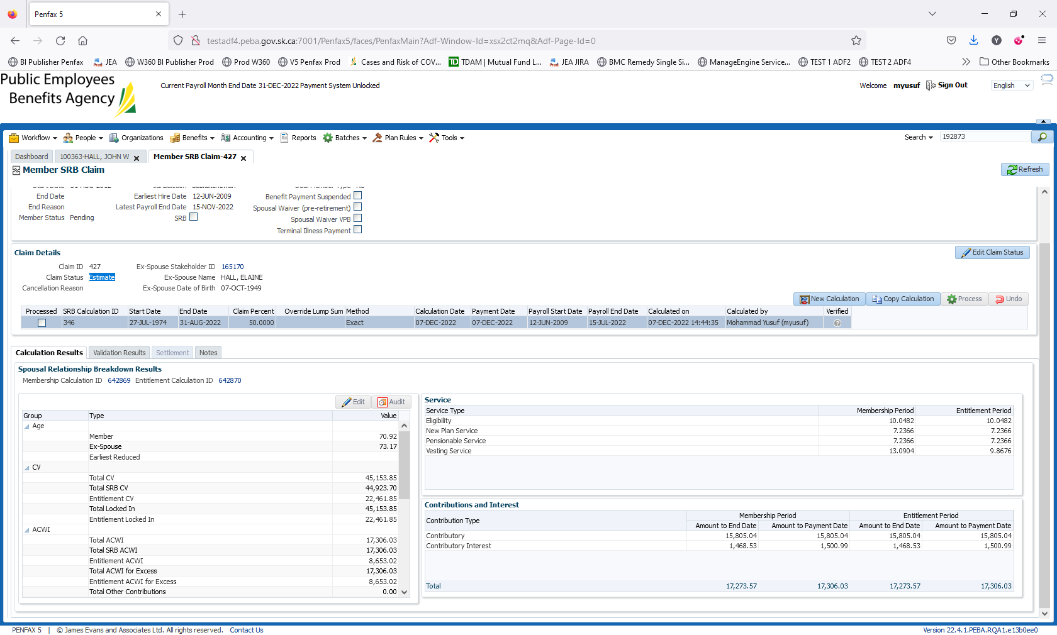

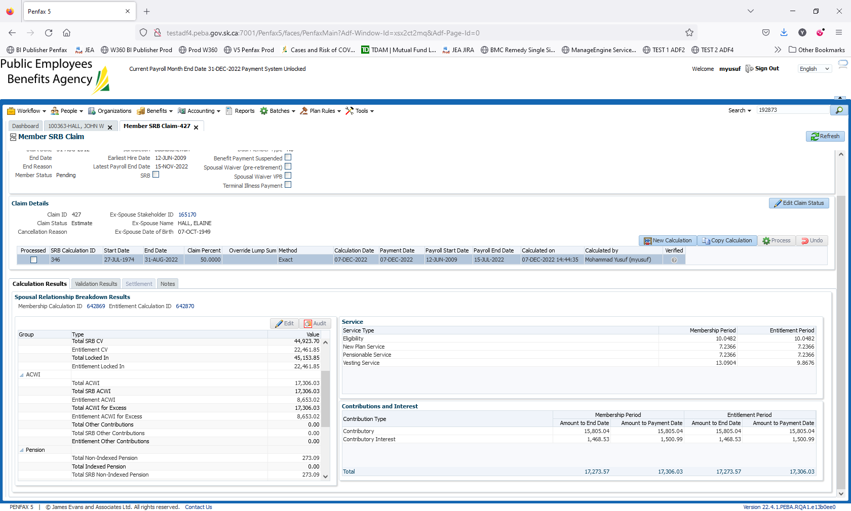

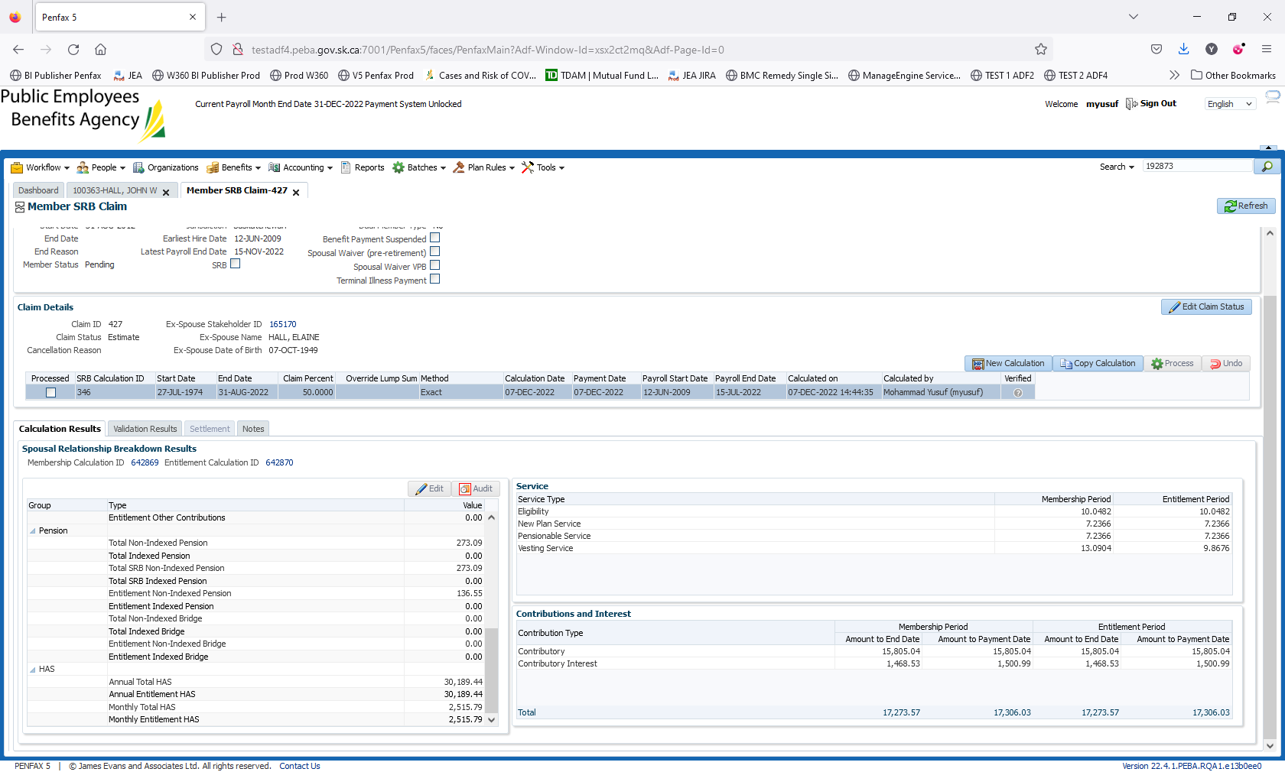

The calculations piece displays the division among the member and spouse

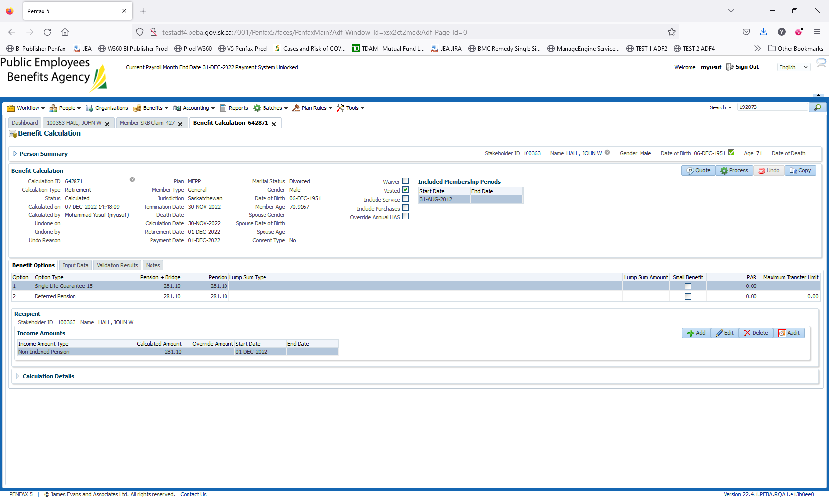

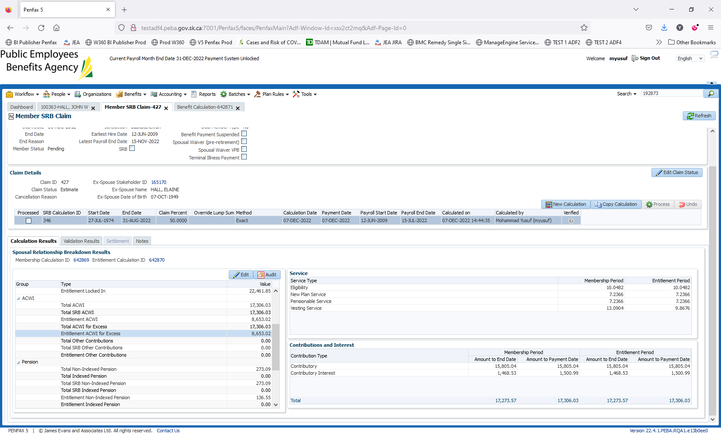

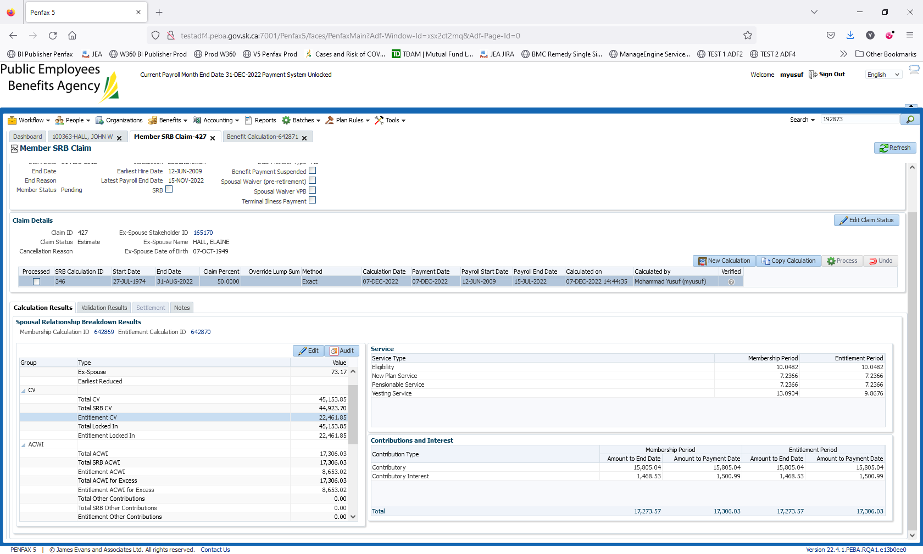

Click on X to exit out the claim